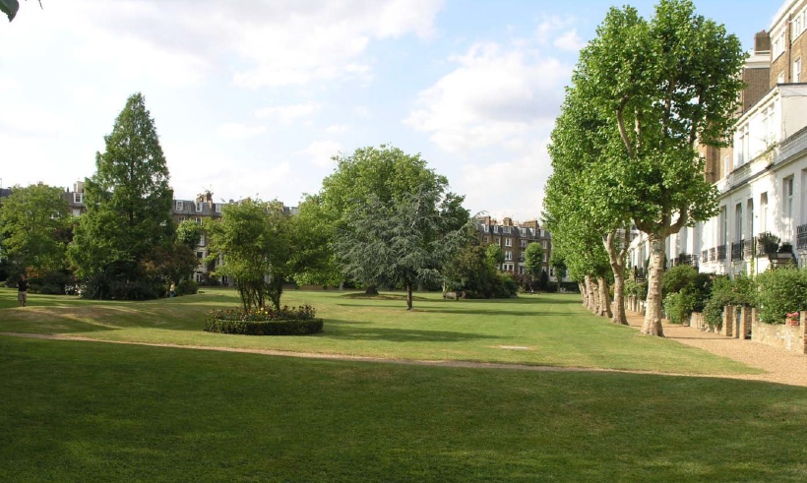

Proposed Long Term Management Plan for Formosa Amenity Garden, London W9

Submission to Westminster City Council by the Directors of Formosa Amenity Ltd, November 2015

Table of Contents
1 Executive Summary 3
2 Introduction 6
2.1 Purpose 6
2.2 Context 6
2.3 Consultation 7
2.4 Who has been involved 7
3 History 8
4 Current Position 9
5 Issues 10
5.1 Subsidence 10
5.2 Effectiveness of pollarding 10
5.3 Longevity of trees 11
5.4 Aesthetics 11
5.5 Shade 14
6 Solution Options 15
7 Proposed solution 16
7.1 Rationale 16
7.2 Overview 16
7.3 Implementation 18
7.4 Benefits 22
8 Consultation 23
9 Approval sought 25
10 Recommendations 26
References 27
Appendix 1: Formosa Amenity Gardens: The New Garden, Mark Lutyens Associates, September 2015 28
Appendix 2: Report on Trees at Formosa Amenity Garden London W9, Simon Jones Associates, August 2011 29
Appendix 3: List of consultations 30
Appendix 4: Surveys of property damage 31
Appendix 5: Reports on trees associated with subsidence at 26/28 Warrington Crescent, H Paul Arnold, August 2005, October 2006 and December 2006 32
Appendix 6: Letter from Westminster Council – informal advice on tree pollarding 8 May 2007 33
Appendix 7: Brief to potential garden designers, 2012 34
Appendix 8: Extract from WCC draft Tree Strategy 35

Executive Summary

The Formosa Amenity Garden covers some 4 acres of paths, grass, trees, shrubs and other plants in London W9. It is bounded by Sutherland Avenue, Warrington Crescent and Castellain Road and was established in the late 19th century as residences were built on land owned by the Church Commissioners. Since its establishment it has served a number of purposes for the local community, including a place to relax and meet other residents, a space to play games, and a source of firewood. It continues to fulfil most of these purposes and is also used as a focal point for community events such as the annual firework display and the summer fete. However, our community is faced with a long term issue with the trees in the Amenity space, and we are reaching out to Westminster Council for help and support for our residents.

Some 85 properties surround the Formosa garden, most split into flats. The freeholder of each property has the right to vote on matters raised at General Meetings. In total it is estimated that some 700-800 adults and children live in these properties, the majority having access to the Formosa Amenity Garden, either directly or via an access gate situated on Castellain Road. Most properties have a small patio garden that adjoins the communal Formosa Amenity garden. The garden and surrounding properties are built on what was originally water meadow owned by the Church Commission. The subsoil is London Clay, which has a high shrinkage potential. The properties surrounding the garden were built in the second half of the 19th century to then prevailing building standards. Foundations are shallow by modern standards, at between 750mm and 1300mm.

Some 48 mature London Planes plus 4 other mature trees are sited round the perimeter of the garden, many on the Warrington Crescent side being no more than 6 metres from the adjacent dwellings and the majority of the remainder within 13 metres. Until the Clean Air Act in 1956, the perimeter trees were used as a source of firewood and kindling and were pollarded regularly to a height of 2-3 metres. With the banning of open coal and wood fires regular pollarding ceased and the trees grew rapidly to a height of over 20 metres by the 1970’s.

At least 16 of the properties around the garden have been underpinned following subsidence. Over the years there has been considerable debate and controversy about what caused this damage. Some say it was because of a combination of the nature of the subsoil, the shallowness of the building foundations and the root systems of the perimeter trees extracting large amounts of water from the ground during summer. Others say it is the much larger trees on the pavement side that are responsible. Some say it is the grass that soaks up the water. Whatever the cause, some of these cases have resulted in costs to householders and their insurers in excess of £80,000, and since 1997 at least 6 claims have been made to Formosa Amenity Ltd’s insurance company for recompense for damages caused by the trees. It is not a happy situation for anyone.

Current standards specify that major trees are planted no more than 15 metres away from buildings where the subsoil has a high shrinkage propensity, as is the case with London clay. Almost every single tree round the perimeter of the garden is less than this distance away from the nearest building and 16 of them are less than half that distance.

Action needed to be taken to reduce the risk of subsidence. Given that little could be done to change the nature of the subsoil, and that extending the foundations of all buildings surrounding the garden would be prohibitively expensive, action was taken to limit the amount of water extracted by the perimeter trees. A pollarding regime to a height of around 10m was therefore introduced in 2001 with the agreement of the Council. This has continued, and since the winter of 2007/8 trees have been pollarded on a bi-annual basis. In the absence of this pollarding regime it is estimated that the trees would now be over 15-20 metres tall with a spread of 4-6 metres and a root system extending some 2.5 times the height of the tree. Such trees would represent a serious risk to the structural integrity of the buildings surrounding the garden and would cast large parts of the garden, and the adjacent buildings, into deep shade – over the years residents have frequently requested that perimeter trees be cut back since they were shading their property and their patio gardens.
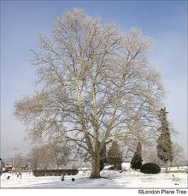
During the bi-annual pollarding regime the perimeter trees display a range of appearances, all of which are far from ideal from a visual amenity point of view. Immediately after winter pollarding the trees are bare and devoid of small branches. The following summer the trees adopt a ‘lollipop on a stick’ appearance. The subsequent winter the trees have many thin, spiky branches and the next summer they have the appearance of a witches broom. All of these are completely unnatural and unfortunately detract from the aesthetics of the garden.
Unpollarded London Plane in winter
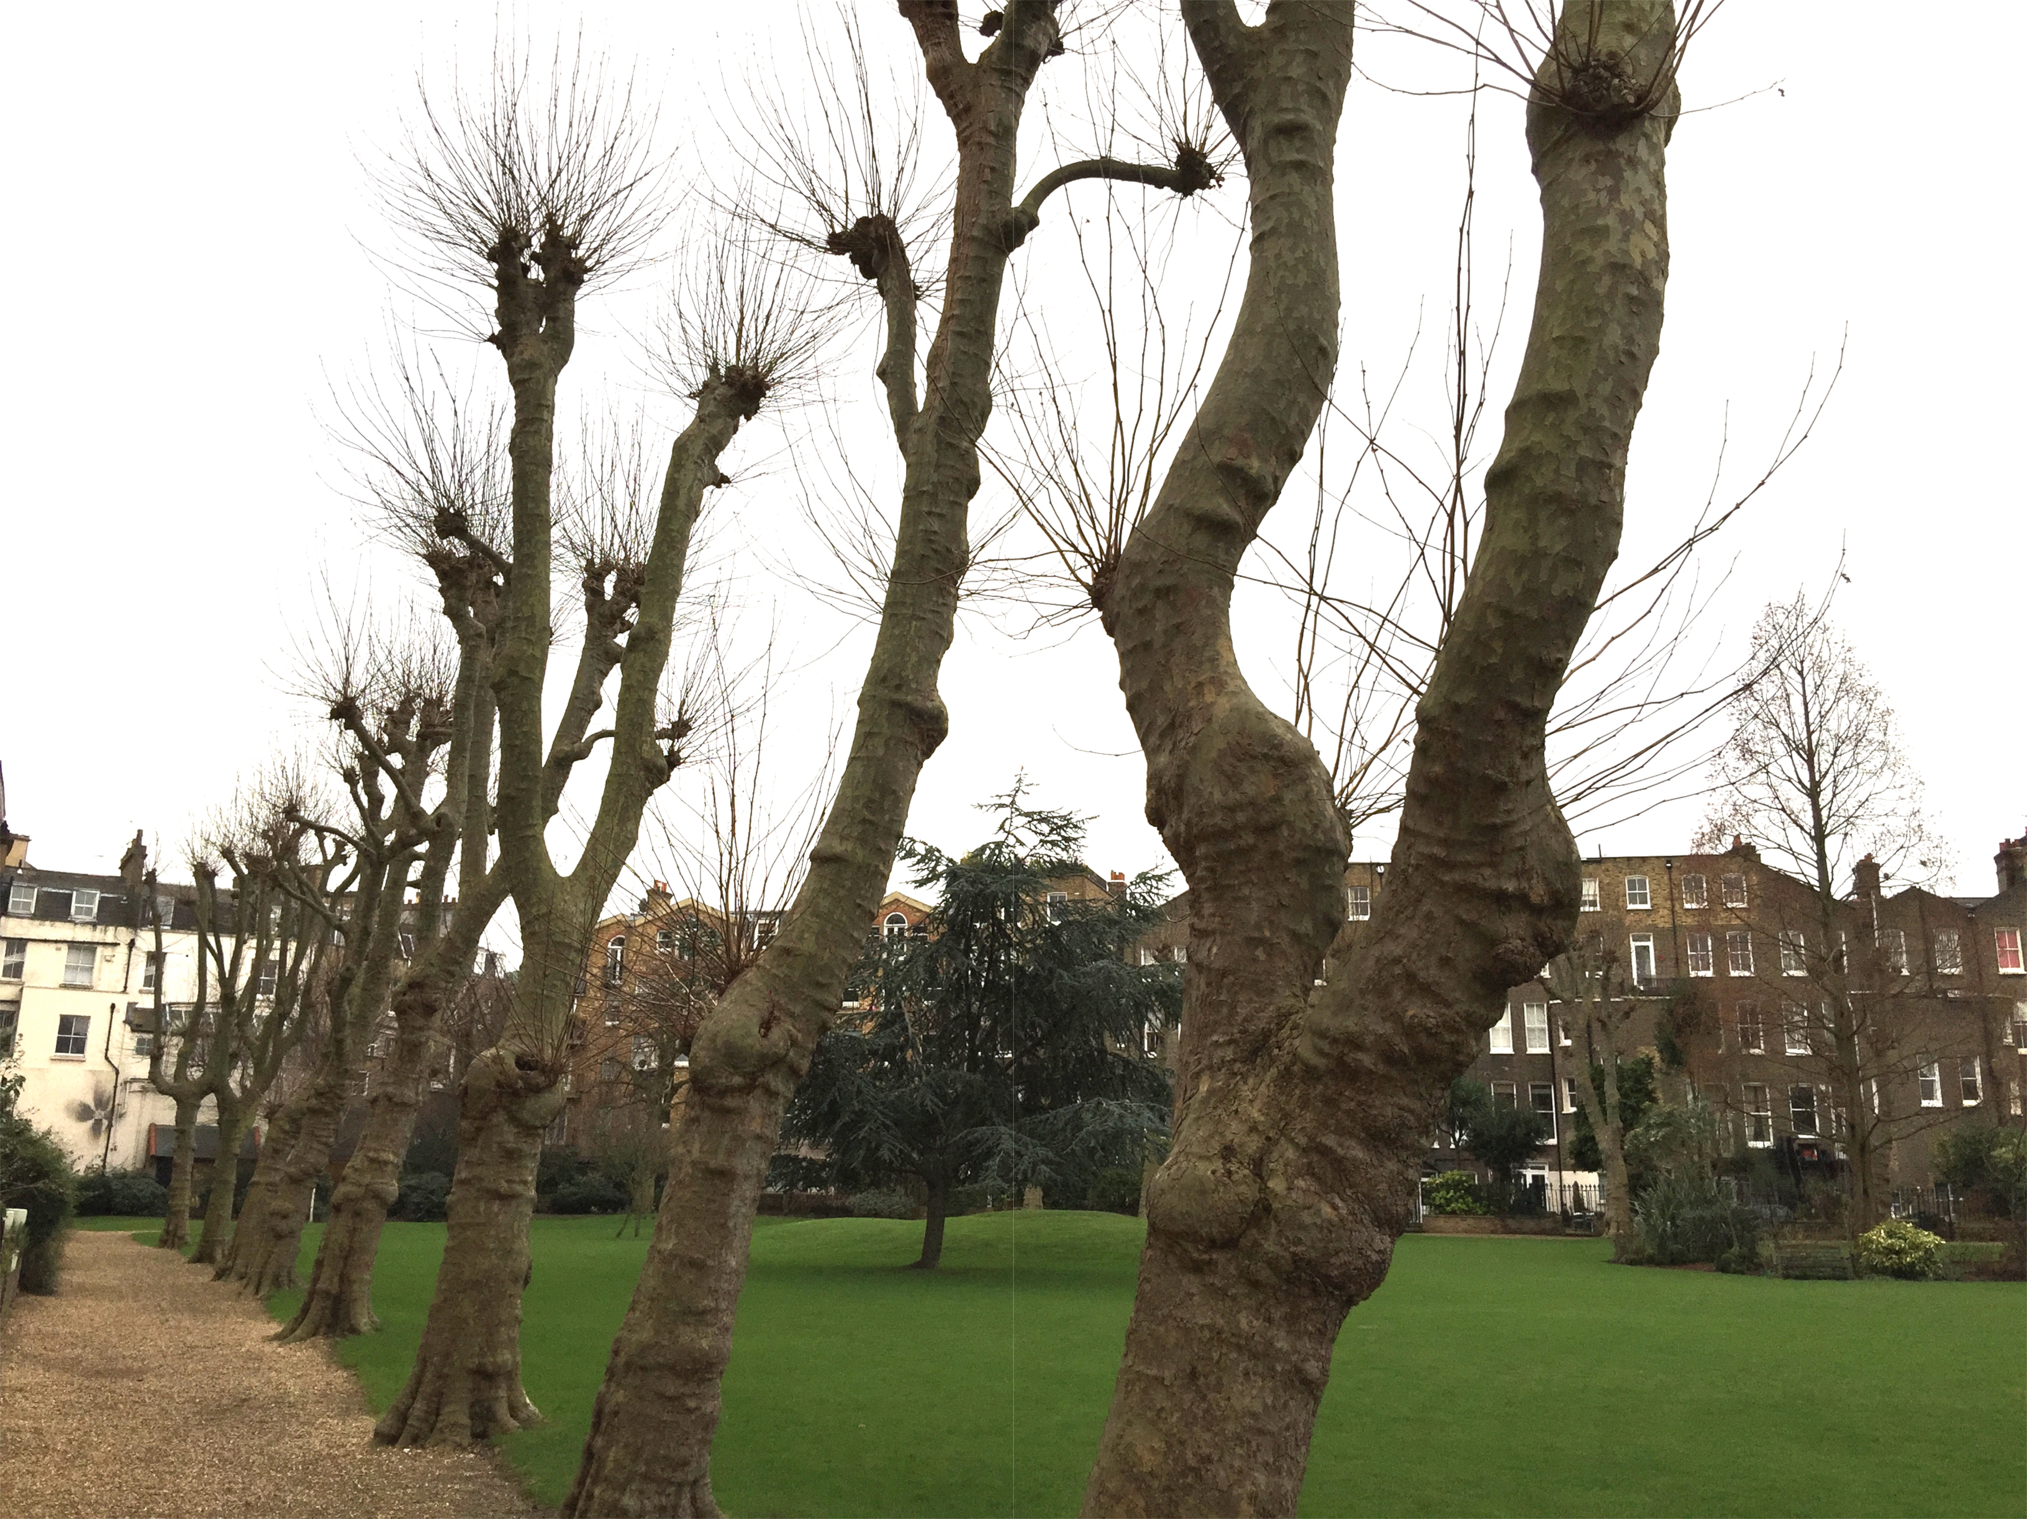
Over time pollarding has weakened the perimeter trees and 2 have died in the last 3 years and have had to be removed with the Council’s approval. An expert report commissioned by Formosa Amenity (ref 1) states that: “the poor structural condition and increasing decay of these specimens leads me to believe that most are unlikely to survive for more than another 40 years”
Formosa London Planes in winter
For every tree that dies, or becomes a danger to health and safety, Formosa submits an application to the Council for its removal, cumulatively resulting in significant expenditure of time by the Council’s officers and members.

Given the issues of subsidence, evolution in the use of the garden, aesthetics and the impact of shade on many properties if trees were allowed to grow in an unmanaged fashion, the Formosa Amenity Board therefore identified the following major options:

Option A: Continue to pollard the trees in an attempt to limit water abstraction and therefore the contribution to the risk of subsidence, in the knowledge that this would impact on the life of the remaining trees, requiring the ongoing and ad hoc replacement of dead trees, with the likely and eventual repetition of the same problem as the replacement trees mature. This would cost our community in the region of £5,000-10,000 a year on average over the next 40 years.

Option B: Develop and implement a sustainable long-term strategic solution that addresses the problems of subsidence, visual amenity, die-back and shade. This would also be the most cost effective solution for our community over the long term.

The Board believed, and continues to believe, that the Option B is in the best interests of the local community and, following consultation with residents, accordingly commissioned a respected firm of garden designers (Mark Lutyens Associates) to develop options and proposals for a sustainable solution that retained a substantial proportion of the current number of trees in the garden whilst avoiding the risk of subsidence, enhancing the ambience and aesthetics of the garden and being environmentally sound.

The board has issued draft schemes by Mark Lutyens Associates to the freeholders and residents of the community surrounding the garden on 2 separate occasions for consultation, and at each iteration feedback has been incorporated. The proposal submitted in this document has the unanimous support of the Formosa Board and over 96% of those that attended the last public meeting on the topic.

In summary, the proposed scheme will:
- Reduce, over time, the risk of subsidence in the properties surrounding the garden.
- Substantially enhance the visual amenity value of the trees in the garden.
- Be sustainable in the long term without recourse to pollarding or other unnatural tree management techniques.
- Provide continuity of amenity value without leaving obvious ‘gaps’ during its implementation.
- Continue to provide open spaces for community events such as the annual fireworks display and the summer fete.
- Increase biodiversity.
- Ameliorate the issue of excessive shade in some patio gardens whilst maintaining adequate shade in other patios, and providing shade in parts of the communal areas of the gardens.

If approved, implementation of this scheme would take place in a progressive fashion with the foundations of the plan being laid in Phase 1 over the next 5 years. This first phase would involve the planting of 80 trees across the Amenity garden. Phase 2 would build on these maturing foundations, with the existing perimeter London Plane trees being removed gradually over a period of 35 years so as to maintain the general leafy feel of the garden. Plans are provided in an attachment to this report.

The Planning Committee is invited to approve the implementation of this proposal over the next 40 years, and to delegate authority to the Westminster Council officers to approve deviations from the plans incorporated in this document, and to decide to refer any such applications to the Planning Committee for approval.

Ideally, we would like the entire multi-year scheme approved such that we would not need to keep coming back to Westminster every time we wanted to fell a tree. However, we recognize this may not be acceptable to Westminster, so we are hoping that the Planning Committee could agree to delegate authority to Barbara Milne to determine planning applications for trees to be felled in line with our masterplan on a case by case basis. We also recognise that our scheme is not likely to be similar to other tree or planning applications, and therefore some different approval approach may be needed.
After many years of consultation with residents and formulating this plan, the Board does not want to be in a position whereby there is a risk of the entire scheme being rejected simply because of the approval process mechanism rather than the overall scheme plan itself, so we would welcome your feedback, and we would assure the Committee that we are open to ideas as to how to move this forward.

Introduction

Purpose
The purpose of this document is to secure the approval of the Planning Committee to implement a revised design for the Formosa Amenity Garden that will involve the planting of major new trees and the creation of new herbaceous beds, together with the progressive removal of the existing mature pollarded London Plane and other trees over the next 40 years as they reach the end of their natural lives.
The paper will describe the history of the garden, past and ongoing issues relating to the garden trees, options considered to resolve these issues and other matters relating to the rationale for the proposal. The proposed scheme is described in detail in Appendix 1.

Context
The Formosa Amenity Garden covers some 4 acres of paths, grass, trees, shrubs and other plants in London W9. It is bounded by Sutherland Avenue, Warrington Crescent and Castellain Road and was established in the late 19th century as residences were built on land owned by the Church Commissioners. Since its establishment it has served a number of purposes for the local community, including a place to relax and meet other residents, a space to play games, and a source of firewood. It continues to fulfil most of these purposes and is also used as a focal point for community events such as the annual firework display and the summer fete.

Some 85 properties surround the Formosa garden, many split into flats. As shareholders in Formosa Amenity, each freeholder of these properties has the right to vote on matters raised at General Meetings. In total it is estimated that some 700 adults and children live in these properties, the majority having access to the Formosa Amenity Garden, either directly or via an access gate situated on Castellain Road. All properties have a small patio garden that adjoins the communal Formosa Amenity garden.

The garden and surrounding properties are built on what was originally water meadow owned by the Church Commission. The subsoil is London Clay. Analyses of samples taken from various locations in or adjacent to the garden show that the clay has Plasticity Indexes ranging between 41% and 54% (see Appendix 2 section 4.3). This represents a soil of high shrinkage potential as the amount of water absorbed in the clay reduces.

The properties surrounding the garden were built between 1865 and 1895 to then prevailing building standards. Foundations were not designed to allow for the impact of trees on the subsoil and are relatively shallow, at around 750mm for the older properties along Castellain Road, between 900 and 1000mm for the houses on Warrington Crescent and up to 1300mm for the later properties along Sutherland Avenue. (see Appendix 2 section 4.4)

In published standards (ref 1), the National House-Building Council recommends minimum foundation depths for house foundations on shrinkable clay soils where these are sited close to trees. This is based on experience gathered on many sites where building subsidence has occurred, and trees have been shown to be implicated in this damage. The recommended minimum depth for buildings on London clay as close to mature London planes as those along the Warrington Crescent side of the garden would be 2.0m, compared with the existing foundations at 750mm.

Consultation
The shareholders of Formosa Amenity and residents of the properties surrounding the garden have been consulted on the proposals in this document at various stages throughout their development since 2010. Through Annual General Meetings, ‘Town Hall’ meetings and other forms of personal interaction and online/web correspondence the community has been given the opportunity to:
- Comment on the need for an alternative course of action to that currently in place
- Input to the development of alternative courses of action
- Suggest suitable garden designers and approve the preferred designer (Lutyens Associates)
- Comment on draft designs

The currently proposed design is the result of 3 formal iterations, with community feedback incorporated at each stage. The proposed design was endorsed by residents at an Annual General Meeting on 6 June 2013 and formally approved at that meeting by shareholders. Information relating to the garden redesign has been available on the Formosa Garden website which is open to the public (www.formosaamenity.co.uk) since 2013.

Details are given in Appendix 3.

Who has been involved
The proposed garden design has been developed by Mark Lutyens of Lutyens Associates Ltd, working with members of the Formosa Amenity Board of Directors. The current design incorporates inputs from around 50 individual residents, and we know that many of these residents have discussed with fellow residents so they represent a very broad base of opinions.

Notwithstanding the entirely expected personal biases of the average resident, the views of the residents as a community have been remarkably uniform. They are concerned with the appearance of the garden and the “lollipop sticks” that we have for trees, they don’t like how much it costs each year to pollard and maintain the trees, they want a long term solution, they want shade (because when we get strong sun the current London Plane trees provide precious little protection), but they want the two remaining large open areas of the garden to stay open. This last part is an important difference between our garden and, say, the Crescent Amenity garden. Our community very much supports young children being able to kick a football around, or to throw a frisbee. It also very much supports allowing dogs off leads (before 10am), and letting them run free in open space. As mentioned earlier, we have a very longstanding tradition in our community of hosting an Annual Summer Fair, with bouncy castles etc., and a Fireworks Night. Such social uses of the garden are of very high amenity value to our community, and so the proposed design and the feedback from our residents reflects this long standing pattern of use.

History
The area currently known as Maida Vale belonged to the Bishop of London from the 17th century, and was occupied by tenant farmers who paid rent to support the stipends of local clergy. Building in the area was made possible by an Act of 1795, and the bishop’s estate started the first developments along the Edgware Road in the early 19th century.

It is understood that the Formosa Garden was created and planted in the late 19th century, in line with the completion of building in the streets that surround the garden. The southern parts of Warrington Crescent and Castellain Road were competed in the 1860’s, with Sutherland Avenue and the remainder of Warrington Crescent completed in the 1890’s. The plans for the area specified that builders were to help the purchasers of properties to lay out the communal gardens.

The occupants of the properties surrounding the garden were classed as ‘wealthy’, and the developers of the Paddington Estate found that houses constructed around attractive communal gardens were more desirable than those without. In addition the gardens were a source of firewood and kindling, and an annual regime of pollarding the perimeter trees to a height of 2-3m ensured a regular supply of wood. The area continued to be one of London’s most desirable areas until after the Second World War, when many of the large mansions started to be converted into flats, a trend that continued through to the 1980’s. In the 1960’s and 70’s, the GLC cleared a number of sites in the area to make way for blocks of council flats, and a number of further proposals to build large blocks of flats in the area were defeated.

In the mid-1970’s the Church Commissioners made proposals to ‘improve’ what was then their Maida Vale Estate, including the conversion of some of the communal gardens to car parks. Discussions were held with the Church Commissioners in 1983 on a specific proposal to use Formosa Garden as a site for an underground car park.

In 1981 the Church Commissioners decided to sell the entire Maida Vale Estate and the properties surrounding the garden were sold off progressively during the 1980’s. Many of the houses were bought by property developers who converted them into flats. To continue to preserve the ambience of the area, the Commissioners drew up complex legal arrangements based on Rent Charge Deeds, which were to be enforced by Amenity Companies, one of which is Formosa Amenity Ltd. Since 1982 the garden has been managed under the auspices of Formosa Amenity, who are responsible for its upkeep.

The Clean Air Act of 1956 stopped the use of open fires and the annual pollarding of the perimeter trees ceased. The trees then grew rapidly to a height of around 20 metres and the condition of the gardens deteriorated to the point where they were being used as a dumping ground for rubbish. Tree pollarding resumed in 1972, followed by further pollarding in 1978. Between the late 70’s and 90’s we believe some pollarding was done. In more recent years the perimeter trees were pollarded in 2001, 2005, 2007, 2010, 2012 and 2014.

In December 1992 a Tree Preservation Order was made covering all the mature trees in the Formosa Garden.

Current Position
Formosa Amenity Ltd have returned the garden to a neat and tidy state and it is now enjoyed by many in the local community. Subject to Council approval, the perimeter trees are pollarded every two years, and there is an ongoing programme of maintenance and improvement for all beds in the garden.

The garden is used all year round by residents and their families for taking exercise, walking dogs, and enjoying the scenery. In summer it is enjoyed by many residents as a place to sunbathe, meet friends and take picnics. The large open spaces provide an excellent place for children to play games in a safe, enclosed environment away from any traffic. The Formosa Board has for 20 years organised an annual summer fete, attended by both residents and many in the local community. Similarly, the annual November 5th firework display has attracted crowds of up to 500 people from the local community since 1994. Other events held in the garden include a Christmas Carol concert and the gardens take part in the national open gardens scheme. In addition, the ornamental nature of the garden provides pleasing views from the surrounding properties.

The garden is considered a substantial asset to the surrounding properties, as reflected in property prices compared with similar properties without access to communal gardens.

Residents have long held the view that the open spaces in the garden are a key feature which makes it such a valuable amenity, making a difficult balancing act between maintaining this value whilst also having a sufficient number of trees.

The final plans have evolved following consultations and votes from shareholders and residents to the point where we now feel that the plan achieves this balance.

Issues
Despite the best efforts of Formosa Amenity a number of issues exist in relation to the perimeter trees. These are described in the following paragraphs.

Subsidence
There is evidence of subsidence affecting the properties surrounding the garden. Surveys carried out in 1997 and 2011 (Appendix 4) reveal that 44 of the 86 properties surrounding the garden had suffered cracks in their structure and 17 properties had been underpinned. Over the past 20 years there have been at least 6 claims against Formosa Amenity.

The major factors involved in subsidence are:
- The nature of the underlying soil: this consists of London clay, which has a high shrinkage potential
- The depth of the foundations, which vary from 750mm to 1300mm. Although these depths were standard practice in Victorian times, they are substantially less than the 1900mm that would be used for buildings close to trees in London clay subsoil today
- Abstraction of water by trees and other plants in the garden

Whilst none of these factors alone would necessarily account for the significant level of subsidence evidenced above, it is argued by some that the abstraction of water from trees in the garden is a contributory factor. Expert arboricultural consultants (see Appendices 2 and 5) have expressed the view that, taking into account the locations, sizes, physiological condition and likely root disposition of the perimeter trees it is likely that most of them will have roots growing adjacent to and possibly even beneath the foundations of the surrounding houses. As the soil is of high shrinkability, and foundation depths are small, there is a possibility that the trees may have contributed to the subsidence damage that has occurred.

Whether the trees are responsible for subsidence or not, the Formosa Board feels it has no option but to seek advice that is very likely to result in (and has actually resulted in) bi-annual pollarding of the London Planes.

Effectiveness of pollarding
As indicated above, the perimeter trees have been pollarded at various stages during their lives, initially on an annual basis to a height of 2-3m, then at an increasing frequency since the 1980’s. Since the early 2000’s the trees have been pollarded every two years to a height of around 10m. As the trees have been regularly pollarded expert advice (Appendix 2) is that their integrity is compromised due to weakened growth points for their branches. The irony now is that it would not be safe to leave the trees unpollarded.

Evidence from other studies (unrelated to Formosa) suggest that the pollarding regimes are only partially successful in reducing the amount of water extracted from the subsoil close to inhabited buildings. The Horticulture LINK project (ref 2) concluded in its final report that tree water use was reduced by pollarding, but that trees recovered their canopy leaf areas to pre-pruning amounts within 1-3 years. The effect of pollarding was significant in the year of pruning, but was generally small and disappeared within the following season. If Formosa’s case, no such evidence is available, but cosmetic works as a result of building movement have been reported from nine properties over the last few decades and many residents report to us that damage continues to occur, even though the trees have been regularly reduced and controlled in size during this time.
It could be argued (and some have) that putting the regime onto an annual cycle would produce a significant reduction in water uptake from the soil. However, Westminster City Council have indicated (Appendix 6) that they would not be in favour of this approach. In addition, the removal of all growth every year would further diminish the energy-producing potential of the trees, whilst actually increasing their need for energy by producing more frequent wounding; this would further reduce their expected lifespan (see section 5.3 below). Furthermore, there would be a significant reduction in the visual amenity provided by the trees, in that only one year’s growth would ever appear, reducing the contribution the trees make to the character and appearance of the garden. This factor is explored further in section 5.4 below. Last, but not least, this would significantly increase the financial burden on the community.

Longevity of trees
The perimeter trees are all well over 100 years old and have been subject to pollarding, to various heights, through most of their lives. In the last 3 years 2 trees have died or become dangerous as a result of pollarding and have had to be removed. Every tree removal requires a planning submission to the Council under the Tree Preservation Order, resulting in significant expenditure of time by the Council’s officers and members.

A recent survey of the perimeter trees (Appendix 2) reported that the regular removal of shoots and branches as part of the re-pollarding regime has resulted in the plane trees being wounded on a consistent and regular basis. The regular removal of the energy-producing parts of the trees (the leaves) reduces the amount of starch the trees produce. Two thirds of the perimeter trees already have significant cavities. This condition is consistent with them no longer having enough energy-producing potential to produce sufficient starch to enable efficient healing of pruning wounds and the effective resistance to decay.

The effect of this is that the trees are in a spiral of decline, and are unable to prevent the spread of decay that has started at the sites of pruning wounds. This decay will continue to spread, probably at an increasing rate over time, and this is likely to result in many specimens having to be removed for safety reasons in the future. In the arboriculturalist’s expert opinion most perimeter trees are unlikely to survive for more than another 40 years.

Aesthetics
As shown in the Figures 1 and 2 below, the pollarding regime has resulted in the perimeter trees adopting an unnatural appearance compared with trees that have been allowed to grow to maturity in a natural state. It is clearly no longer correct to describe these trees as ‘magnificent avenues’ as some objectors to tree felling have indicated in the past. The collective appearance of the trees is as artificial as the straight lines of conifers planted by the Forestry Commission in the past and is far from what the Victorian designers of the garden would have envisaged.

Sadly our trees will never again look magnificent. Too many were planted, too close to each other, and way too close to the buildings, for this to be a realistic outcome. Our residents understand this and agree that our trees are in a sad state of repair. To quote one resident, their fear now is that “the lollipop sticks begin to look like a drunken sailors teeth….full of gaps !”

Rather than rectify one rotten tree at a time, we think a holistic, long term, carefully thought through plan is in everyone’s interests, and will leave us with a magnificent garden that our children, grandchildren and future generations can enjoy.
Fig 1: Comparison of unpollarded London Plane (top) with pollarded Formosa London Planes in winter

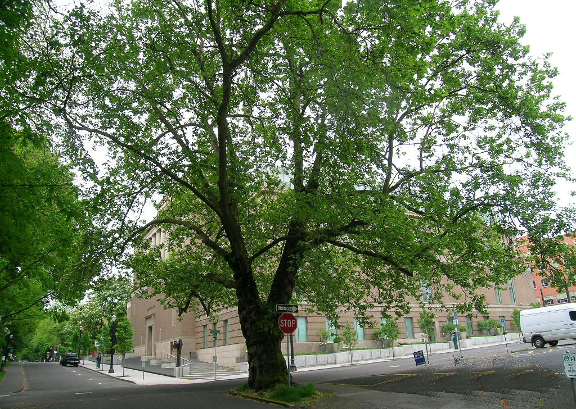

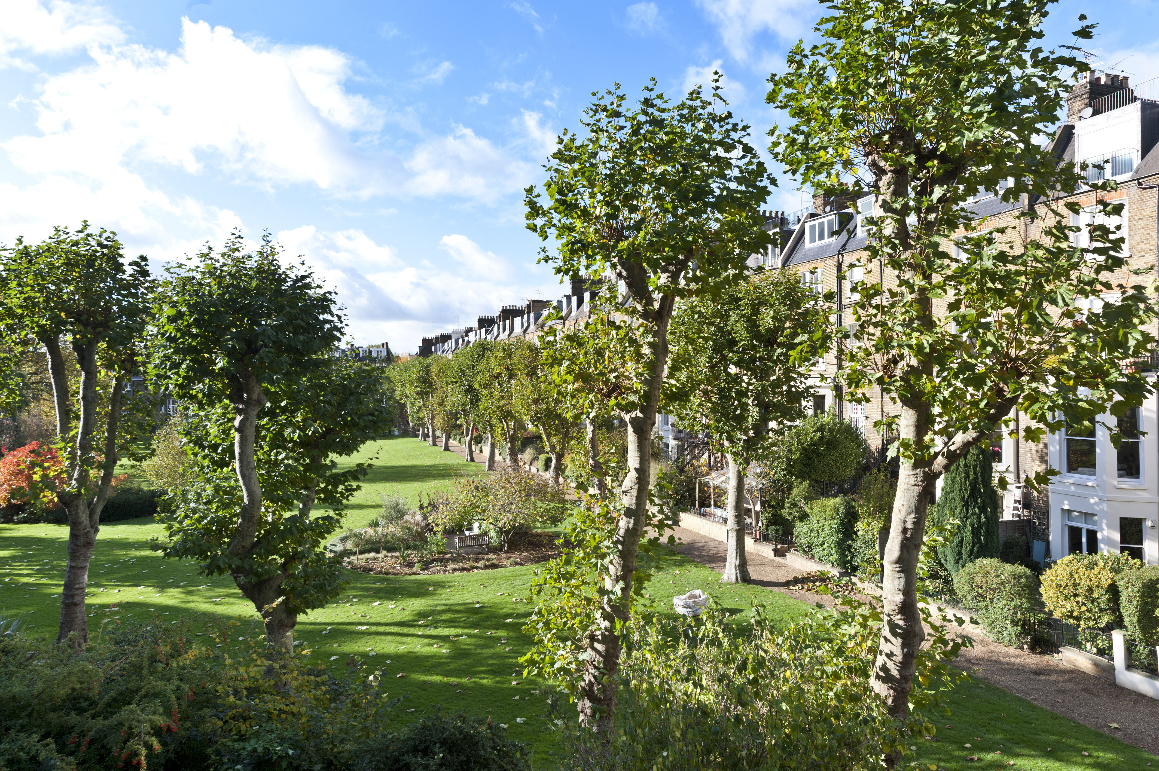

Fig 2: Comparison of unpollarded London Plane (top) with Formosa London Planes in summer

Shade
A number of residents around the garden, particularly those on the Sutherland Avenue side, have expressed concerns about the extent of shade on their properties and patios from the perimeter trees. Whilst in the first summer following biannual pollarding the extent of foliage growth is moderate, in the following summer the perimeter trees cast substantial areas of shade through most of the day over the patios, making it difficult if not impossible to grow many plants that need full sunshine to thrive. The resulting effect is to limit the range of plants that can be grown in many patio gardens to shade-loving plants that in general are less colourful than those that thrive in full sun.

For many residents however, they are keen for more shade in the large communal areas of the garden. Sadly, the pollarded trees afford precious little protection from the beat of the Summer sun. They would dearly love some larger trees near the existing beds, and some smaller glades of trees so that they can set out their picnic blankets and be able to use the garden during the summer without frying to a crisp.

We feel that the plan meets this need whilst also keeping the feel and look of the open space which is equally important to many residents.

Solution Options
The Formosa Board has taken on board the residents’ feedback about subsidence in adjacent properties, and that the nature of the subsoil and the shallowness of the foundations are also significant factors. However, there is nothing that can be done about the subsoil, and strengthening the foundations of every property would involve major upheaval for many residents and would be prohibitively expensive.

Given the contribution to the possibility of subsidence that the perimeter trees represent through groundwater abstraction, the Formosa Board considers that they should seek to continue, or indeed extend, the existing bi-annual pollarding regime. As indicated in section 5, this course of action is likely to result in the demise of most of these trees within the next 40 years. It is also clear that the aesthetic value of the perimeter trees is also severely reduced by the pollarding regime. With consideration of these and other factors, including the impact of shade on many properties, the Formosa Amenity Board was therefore faced with the following principal options:

Option A: Continue to pollard the trees on a biannual or, subject to permission from Westminster City Council, on an annual basis. Whilst at least partially addressing the subsidence problem, biannual pollarding is expensive, and has only been partially successful in limiting the rate of water abstraction each summer. Notwithstanding this significant cost, there would still be a risk of further claims from householders for compensation for subsidence. This approach would continue to impact on the life of the remaining trees, with the expectation that every year would see at least one or two trees dying. The replacement of the dead trees on a like-for-like basis would lead to the eventual repetition of the same problem as the replacement trees mature. In addition, the visual amenity of the garden would be adversely affected, with the appearance of the trees far removed from their natural, unpollarded, state. Annual pollarding would reduce the risk further, but would cause additional damage to the trees, shortening their lives further, double the annual cost, and would even more severely affect the visual amenity of the garden

Option B: Develop and implement a long-term, sustainable, strategic solution that addresses the possible problems of subsidence, and the very real issues of visual amenity, die-back and shade outlined in Section 5 above.

The Board believes that the Option B is in the best interests of the local community and, following consultation with residents and Council officers, accordingly commissioned in 2012 a respected firm of garden designers (Mark Lutyens Associates) to develop options and proposals for a sustainable solution that retained a substantial proportion of the current number of trees in the garden whilst avoiding the risk of subsidence, enhancing the ambience and visual amenity of the garden and being environmentally sound.

The original proposal has undergone a number of iterations in the light of feedback from the community and the latest version is described in detail in Section 7.

Proposed solution

Rationale
The design rationale for the proposed new garden is to maintain the current leafy ambience of the garden while continuing to provide some good open spaces for recreation and events and providing a long-term solution to the subsidence, aesthetics and shade issues. In doing so the aim is to progressively replace the perimeter trees with other deciduous trees planted at a distance from all properties sufficient to ensure that communal garden trees can be ruled out as a cause of subsidence in the properties surrounding the garden. In doing so, the aim is to plant in such a way that the trees can be allowed to grow freely without the need for regular cutting back, ie so that they grow as nature intended, with resulting aesthetic and wildlife benefits.

We believe that this approach is in line with Westminster City Council’s draft tree strategy (see extract relating to private gardens at Appendix 8), in particular with reference to the following statements made therein:
- “…… we recognise that some flexibility may be necessary in specific cases, if it is evident that the city’s overall historic character and general environment will benefit. For example, the removal of individual trees and their replacement with others in more suitable positions may be appropriate.”
- “Without careful planning of the tree’s location, as it matures it can sometimes become clear that management of the tree is no longer alleviating the problems that it is causing, whether that be blocking daylight, views, causing a garden to be dominated by shade etc.”
- “The focus here returns to “The right tree in the right place”. Whilst the council will still consider amenity benefit (which tends to be wider), against amenity detriment (which tends to be more localised), the balance will be more likely to be tipped towards the owners’ wish to remove the tree, subject to the long term amenity and biodiversity contributions the replacement tree is likely to make.”

We accept that during the implementation of the new design there may be a period when the short-term impact of losing the perimeter trees may be regarded as more significant than the additional amenity provided by the new plantings. However, this is a strategic proposal that is designed to result in a sustainable garden that is more aesthetically pleasing and does not contribute to subsidence problems, and as such we have the long term outcome in mind.

Mark Lutyens was chosen from several experts who were approached in January 2012 to create artistic representations of the proposal – see Appendix 7.

Overview
The proposed redesigned garden consists of a series of groves, glades and island beds, an open and informal arrangement of flowering trees and mass plantings that in the 18th century would have been called a ‘pleasure ground’.

In the central part of the gardens, the existing trees and borders will be retained and incorporated into the new design but the current perimeter trees – principally pollarded plane trees – will be substituted over time by more manageable specimens planted closer to the centre of the garden. The proposal seeks to find a balance between maintaining a significant number of trees in the garden, not having large species too close to houses, but keeping the look and feel of the open spaces that residents love so much.

There will still be a large open area for events and larger groups but there will also be smaller, more intimate spaces for those wanting peace and quiet. The bonfire mound will be retained.
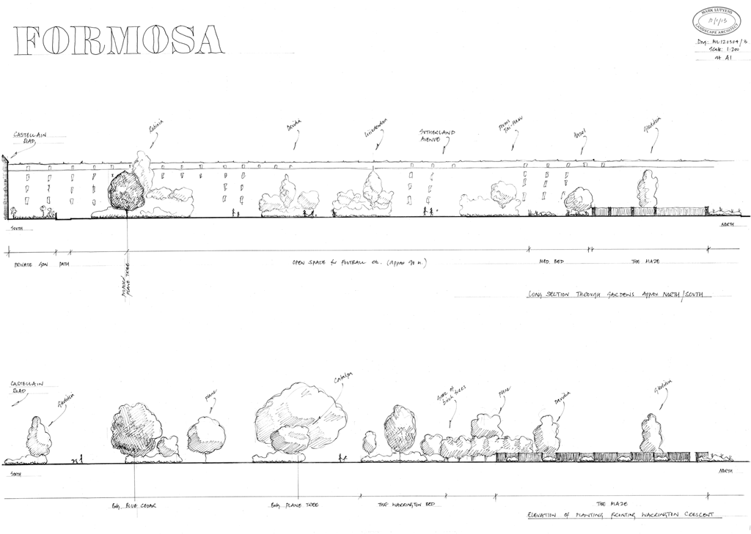
Fig 3: New garden elevations

Views across the site will be filtered by layers of planting, and at a higher level by leafy canopy. All divisions within the garden will be achieved using trees and shrubs – soft screening rather than say, walls or fences.

In order to contrast with the 'busy’ and colourful nature of the many private patio gardens surrounding the communal garden the choice of plants in the new garden – the ‘palette’ – will be restrained, with the main flowering colour white and the leaf colour green.

Broadly speaking there will be four levels or layers of planting:
- Major trees of which there are 14 in addition to the existing 5 in the central part of the garden, including: London Plane, tulip tree, Davidia and Gleditsia
- Small flowering trees and large shrubs such as: crabapple, cherries, lilacs, magnolia, dogwoods and Acers
- A layer of shrub planting which would be predominantly evergreen and grow to a height of 2 metres. This will be the principal screening element, dividing areas and providing protection from the wind
- A ground cover layer which will carpet the ground, which will suppress weeds and provide horticultural interest and colour, a mix of evergreen and herbaceous perennials and bulbs

We are mindful of potential benefits to wildlife, songbirds in particular, and wherever possible we will choose those plants with a high wildlife value.

Implementation
The new garden will be implemented in line with the Council’s guidance contained in its draft tree strategy (see extract in Appendix 8) and adopts the principle of “The right tree in the right place”. The plan will be implemented in in two phases.

Phase 1 (Years 1-5): Phase 1 focuses on building the foundations of the future garden, by planting trees and beds that over time will take over from the current perimeter trees as the dominant features of the garden. The areas in the centre of the communal garden will be planted first; no new trees will be planted less than 15m from a building, allowing them to grow to maturity without impacting on building foundations and without pollarding. A limited number of existing plane trees that have been identified as ‘noticeably hazardous’ by the arboricultural consultant Simon Jones will be removed in order to implement the design plan.

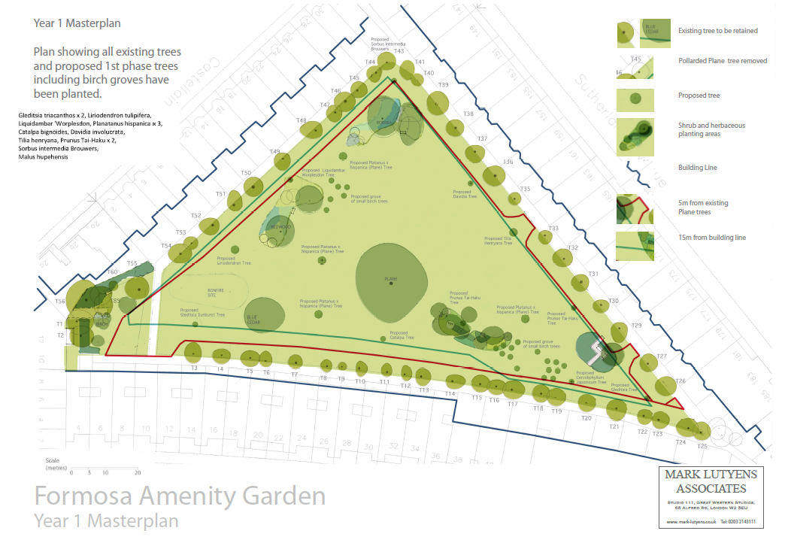
Fig 4: Garden plan after 1 year

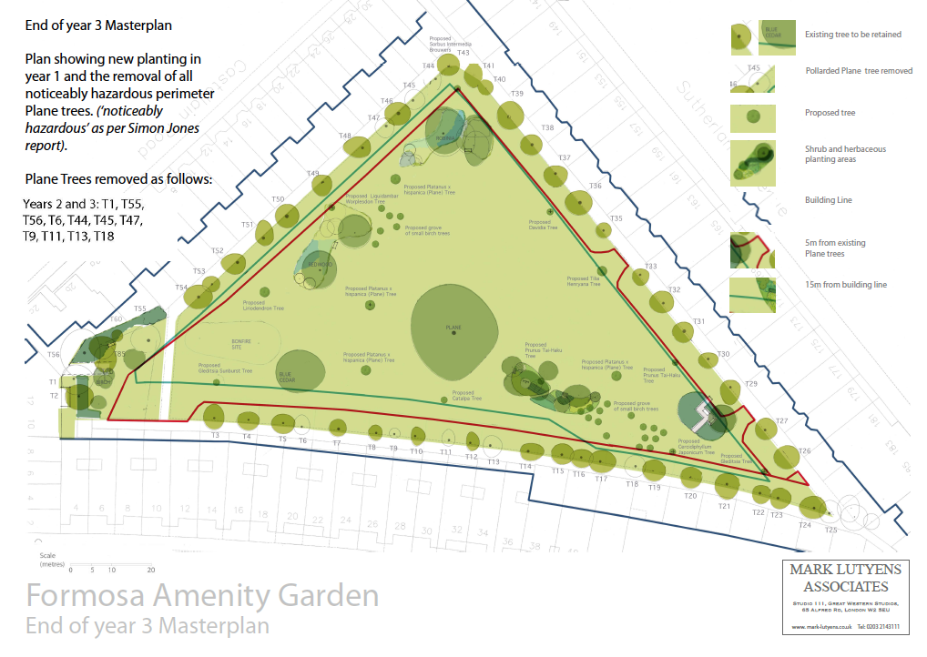
Fig 5: Garden plan after 3 years

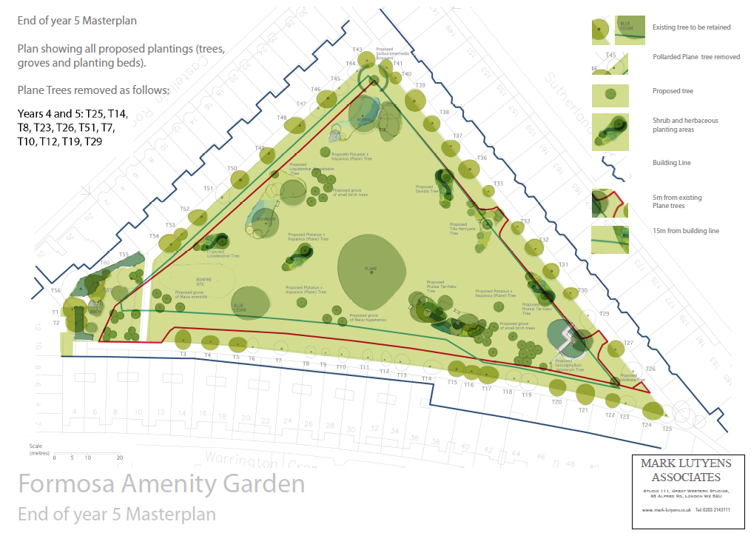
Fig 6: Garden plan after 5 years

Phase 2 (Years 5-50): The second phase sees the progressive realisation of the initial design concept as the foundation planting in Phase 1 matures. Over a period of up to 40 years, and subject to Local Authority approval, the existing pollarded plane trees will be removed. We would start with any remaining trees that are identified as being ‘noticeably hazardous’. Then, as the remaining trees deteriorate, further trees will be selectively removed; Simon Jones has stated that in his opinion, because of their poor condition, all the existing pollarded plane trees would need to be removed over the next 40 years.

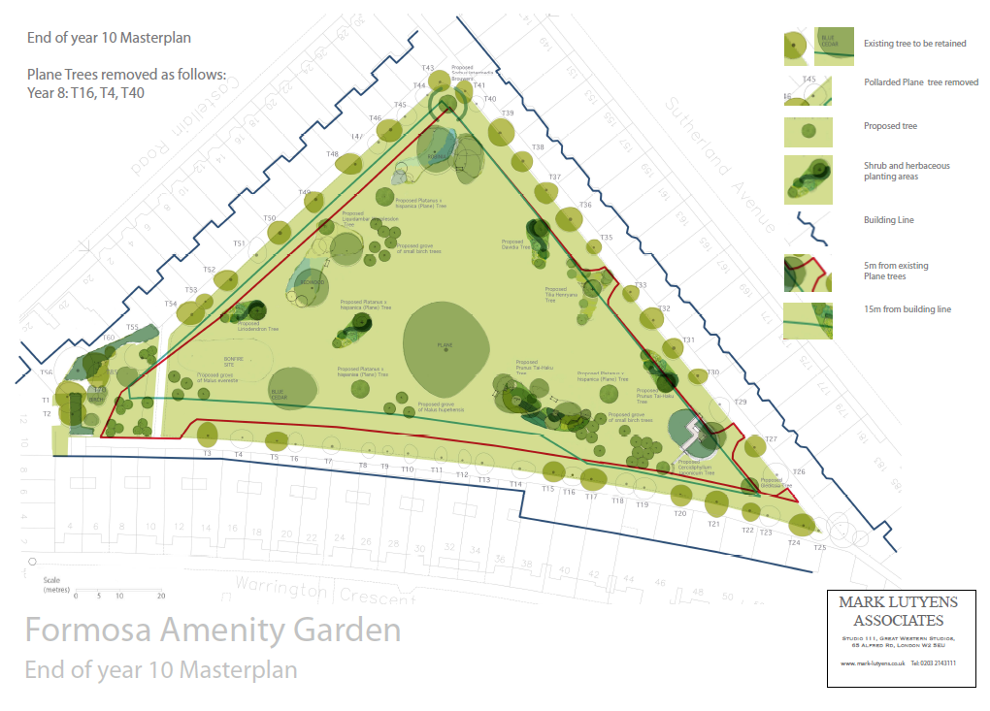
Fig 7: Garden plan after 10 years

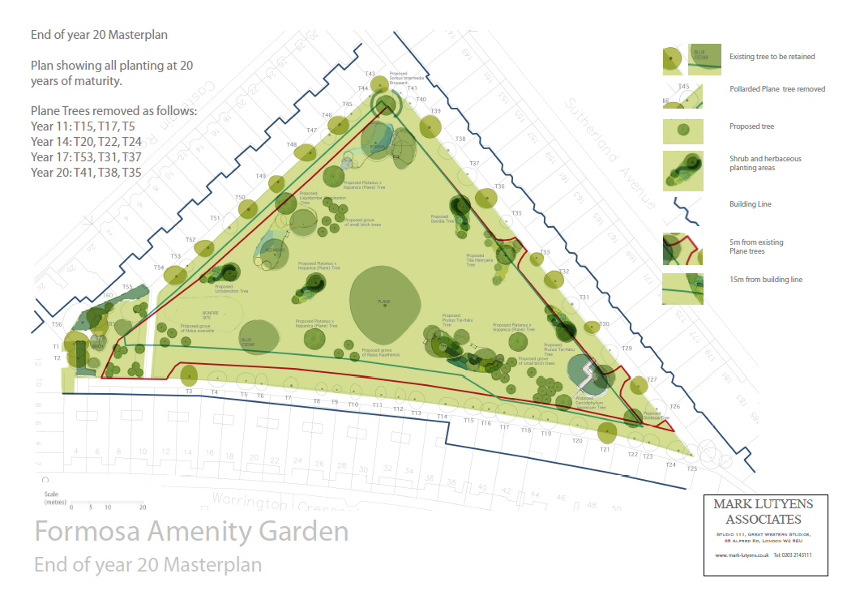
Fig 8: Garden plan after 20 years

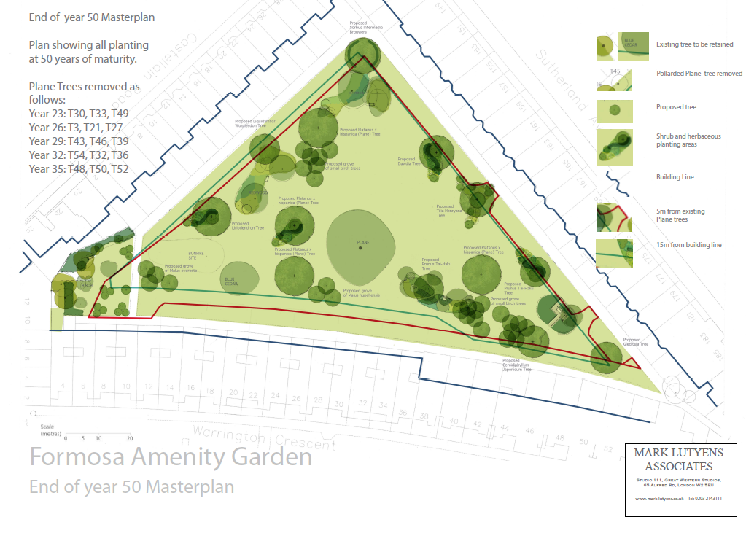
Fig 9: Garden plan after 50 years

Detailed plans, including plant lists and a tree removal schedule, are contained in Appendix 1.

Benefits
The benefits of the proposed garden plan are as follows:
- The risk of garden trees contributing to subsidence in the properties surrounding the garden will, over time, be reduced to effectively zero. This would also reduce the risk to the Council in being implicated in further subsidence claims from residents for refusing to approve the removal of trees.
- The visual amenity and aesthetic value of the trees in the garden will be substantially enhanced, with the existing heavily pollarded trees being replaced by unpollarded specimens that will adopt their natural look and be in better proportion to the size and scale of the site.
- By careful choice of alternative types of tree, the proposed scheme is sustainable in the long term without recourse to pollarding or other unnatural tree management techniques.
- By implementing the plan progressively over a period of 40 years the scheme provides continuity of amenity value without leaving obvious ‘gaps’
- The scheme will also continue to provide open spaces for community events such as the annual fireworks display and the summer fete.
- The new layout will increase biodiversity, in particular in the numbers of different bird species, by specifically choosing types of tees and shrubs that are attractive to wildlife
- The issue of excessive shade in the Sutherland Avenue patio gardens will be addressed whilst maintaining a) adequate shade in the large communal areas, especially for children and families, and b) adequate shade for properties on the opposite side of the garden that receive significant sun in the summer months
- It aligns with the Council’s draft Tree Strategy

Consultation
The proposed scheme has its origins in a discussion at the Annual General Meeting of Formosa shareholders held on 25th June 2010, where it was resolved that the Board would work together with residents to develop options for addressing the problem of subsidence that had been affecting some of the properties surrounding the garden. Many conversations then took place with individuals to get their feedback on ideas for the gardens, and listen to their views. At the Formosa AGM held on 25th May 2011 it was further noted that within the next 30 years many of the mature plane trees may have to be replaced as a result of the bi-annual pollarding regime that had been put in place.

Following a presentation of options for the garden presented by the Board at the AGM on 27th June 2012, attendees voted overwhelmingly in favour of a proposal to develop a long-term plan for the garden that would address the subsidence and other issues. During that Summer, 30-40 residents engaged with the Board to give their feedback and comments. This was a very helpful period of engagement, education and gaining insights on residents’ views. Mark Lutyens Associates were then commissioned to draw up draft design proposals. These were presented to a ‘town hall’ meeting on 27th February 2013 to which all residents were invited (both shareholders and non-shareholders). Following extensive discussion a vote in favour of progressing the new garden design concept was carried 28 for, 5 against. Of the 5 against, most of these residents simply wanted a “second opinion” from Simon Jones Associates that tree removal would not cause issues before they were prepared to vote affirmatively for the proposals. Feedback received at this meeting regarding the design was passed to Mark Lutyens for incorporation in a revised design. As an example, the original proposal of a small maze at the northern end of the garden was rejected, so this was removed from the plans. In addition, there were very vocal calls for as much of the open space to be preserved as possible.

An updated design was presented to the Formosa AGM on 6th June 2013 and a proposal to progress this design through the Westminster City Council planning approval process received 96%support. Subsequently the design proposals were lodged on the Formosa Amenity website and all residents have been encouraged to comment on these proposals. To date a further 15 or so proposed amendments have been received, mostly very minor it has to be said, which have all been incorporated in the final garden design that is contained in this document. One such example was the request by a number of Warrington Crescent residents to remove the proposed teardrop beds on Warrington Crescent and simply put some small groups of trees there instead. Their main desire was for small areas of shade for families and children.

In addition, the Board invited Melvyn Caplan, Councillor, to visit the garden. Two members of the Board conducted a tour, explained the history, explained the need, and asked for his support. Councillor Caplan seemed sympathetic to the community’s needs, but suggested that the originally proposed timeline for removal along Warrington Crescent should be slowed down. This feedback was consistent with feedback from Barbara Milne at Westminster. As a result, the Board agreed to amend the plans, and instead of all Plane trees being removed from the Warrington Crescent side within 5 years, this has now been pushed out to a phased removal over 15-20 years.

The plans were again discussed at the 2014 AGM, but the main issue discussed was the removal of the tear drop beds, which was further requested by one Warrington Crescent resident (and it was confirmed that this feedback had been incorporated). Other residents asked questions about the plans and the discussion developed into a general question and answer session. There was no need for another formal vote at this AGM.

Subsequently, a number of meetings have been held with Westminster’s Arboricultural Officers (Paul Akers and Barbara Milne), which have resulted in refinements to the design and implementation plan that have been incorporated in the proposal in this document. The main change, as discussed above, has been to significantly slow down the removal of the Plane trees along Warrington Crescent from within 5 years, to within 15-20 years.

Following the extensive period of public discussion of this topic, and the evolution of the proposed design following feedback from a significant number of parties, the Formosa Board has confidence that the need for an alternative approach to the management of the garden is widely accepted, and that the proposed design and implementation plan have the support of the vast majority of the local community.

Approval sought
In proposing this scheme to the Council the Formosa Board is seeking approval for the implementation of the full scheme over a 40 year period. Whilst we understand and accept that there may be pressures not to commit future administrations to decisions made now, we do not consider that a piecemeal approach to approving the implementation of this scheme is viable – it stands or falls as a whole. In this context it is not dissimilar to decisions on major buildings or infrastructure, where approval to proceed with a project is given for the whole project and the consequences of that approval have to be lived with for decades, or even centuries, thereafter.

Accordingly, and for the avoidance of doubt, we are seeking planning approval for the implementation of the whole scheme as defined in Appendix 1, including specifically the progressive removal of all the perimeter trees over the next 35-40 years in line with the tree removal schedule included therein. To compensate for the removal of these mature trees, which are all likely to die during this period in any case, we are proposing to plant new trees of species more suitable to the garden context at a safe distance from the surrounding properties together with a number of new beds containing large numbers of shrubs and smaller trees. By doing so we will create a garden that will attract more wildlife (particularly birds), will not need an aggressive maintenance regime and will provide improved visual amenity.

The Formosa Board does accept that the Council will wish to be assured that work is progressing in line with the approved plans, and we will be very happy to report regularly on progress and would be happy to facilitate inspection by the Council’s arboricultural officers on a regular basis. Similarly, there may be a need from time to time to modify the plans, and applications would be made to the Council for such modifications in line with normal planning procedures.

Recommendations
It is recommended that:
- The Council approves the implementation of Phases 1 and 2 of the scheme over the next 10 years for Phases 1 & 2 years in line with the plans in Appendix 1, including the removal of up to 35 perimeter trees during that period
- The Formosa Board provides annual updates on the progress of the implementation plan to the Council’s Arboricultural Manager and facilitates regular inspections by Council officers at a mutually agreed frequency
- The Council delegates authority to Council officers to approve deviations from the plans incorporated in this document, and to decide to refer any such applications to the Planning Committee for approval

References

- NHBC Standards Chapter 4.2 ‘Building near Trees’
- Horticulture Link project 212 ‘Controlling Water Use Of Trees To Alleviate Subsidence Risk’, East Malling Research and University of Cambridge, Final report, May 2004

Appendix 1: Formosa Amenity Gardens: The New Garden, Mark Lutyens Associates, September 2015

See separate document.

Appendix 2: Report on Trees at Formosa Amenity Garden London W9, Simon Jones Associates, August 2011

See separate document.

Appendix 3: List of consultations

Formal consultations were carried out at the Town Hall meeting 27th February 2013, the Annual General Meeting 6th June 2013, and the Annual General Meeting 30th July 2014.

Informal consultations were carried out by Ian Laming with Pat McGrath and others from Warrington Crescent, following which the overall plans were amended to reflect their views. The revised plans were subsequently ratified at the 2014 AGM. The process was reported on again to the 2015 AGM but there were no further questions raised.

Appendix 4: Surveys of property damage

Incidents involving damage to properties that could, at least in part, be attributable to subsidence arising from the abstraction of groundwater by trees are listed in the table below.

Date | Property affected | Value of damage | Description of event | Current position
March 1996 | 151 Sutherland Avenue | £14,000 | Subsidence caused by immediately adjacent tree | Resolved by continuing control of tree roots by pollarding
September 1996 | 18 Castellain Road | N/A | Request for ongoing control of adjacent tree roots following underpinning of property | Resolved by continuing control of tree roots by pollarding
1995 | 30 Castellain Road | £85,000 | House underpinned due to subsidence. | Issue resolved.
April 1997 | 38 Warrington Crescent |  | Request for ongoing control of adjacent tree roots following underpinning of property | Resolved by continuing control of tree roots by pollarding
April 1999 | 26 Castellain Road | £82,000 | Subsidence damage caused by a number of adjacent trees for which Formosa had applied unsuccessfully to WCC for permission to remove | ?
October 2000 | 18-20 Warrington Crescent | ? | Cracks – assurance sought that trees would be subject to regular maintenance programme of pollarding | ?
October 2003 – late 2005 | 26-28 Warrington Crescent |  | Cracks in walls - underpinning required. Arboricultural Consultant report states that principal cause of reported damage is seasonal moisture extraction by adjacent plane trees | ?
2013 – present | 34-36 Warrington Crescent | As yet unknown | Cracks in walls, monitoring ongoing for 2 years. | Cracks continue, reports indicate subsidence caused by roots.

Appendix 5: Reports on trees associated with subsidence at 26/28 Warrington Crescent, H Paul Arnold, August 2005, October 2006 and December 2006

See separate documents Appendix 5A and Appendix 5b.

Appendix 6: Letter from Westminster Council – informal advice on tree pollarding 8 May 2007
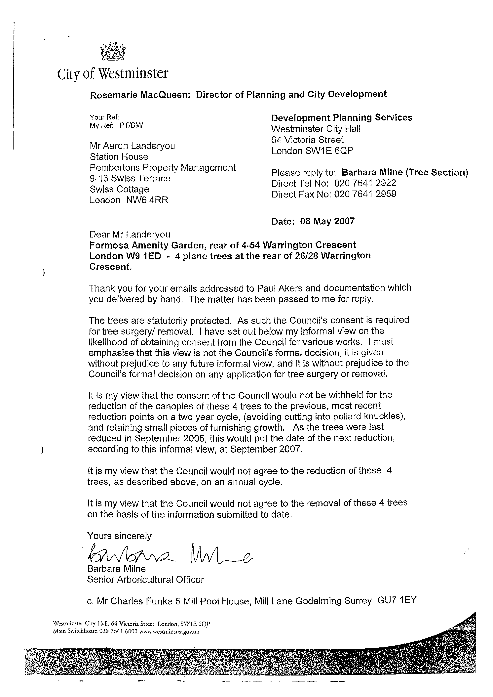

Appendix 7: Brief to potential garden designers, 2012

Dear Landscapers,

Formosa Amenity is a triangular communal garden surrounded by approximately 90 Victorian houses. Currently the garden is tightly edged by London planes but several of these are coming to the end of their days.

The directors of the Amenity are interested in redesigning the garden, gradually changing the planting of the whole over the medium to long term, taking into account the needs and preferences of the residents, subject to permission from Westminster Council for the removal/replacement of existing trees.

Please let me know if you would be interested in producing such a design and overseeing the project. I would be interested in references from any of your clients for whom you have designed gardens of a similar scale and scope, as well as your Ts and Cs and links to any relevant websites.

I am able to make a recent and very comprehensive report on the existing trees and the garden’s layout available to anyone with a serious interest in this project.

Many thanks,

Gill Pyrah

Appendix 8: Extract from WCC draft Tree Strategy

(Appendix F, Trees and the Public Realm – a tree strategy for Westminster (Draft), Westminster City Council, January 2011)

Private gardens
Private gardens can potentially contribute significantly to the streetscape and character of an area. For example, the leafy green gardens of St John’s’ Wood create a characterful environment that enhances the area’s streets, provide visual relief in the built environment, and provide habitat for numerous species that would be unlikely to choose to exist in the area without it.

As part of its commitment to preserve the historic character of Westminster, the council is mindful of the need to retain this tradition. At the same time we recognise that some flexibility may be necessary in specific cases, if it is evident that the city’s overall historic character and general environment will benefit. For example, the removal of individual trees and their replacement with others in more suitable positions may be appropriate.

Certain species of tree are ‘self-seeding’, and these trees in particular can be quite invasive. Without careful planning of the trees location, as it matures it can sometimes become clear that management of the tree is no longer alleviating the problems that it is causing, whether that be blocking daylight, views, causing a garden to be dominated by shade etc. Owners of trees that are causing amenity problems should make the case for removal to our arboriculturalists for the trees’ removal. The focus here returns to “The right tree in the right place”. Whilst the council will still consider amenity benefit (which tends to be wider), against amenity detriment (which tends to be more localised), the balance will be more likely to be tipped towards the owners wish to remove the tree, subject to the long term amenity and biodiversity contributions the replacement tree is likely to make.

Where trees are situated within a Conservation Area or subject to a TPO they are afforded statutory protection under the Town and Country Planning Act 1990. This means that if trees are protected either permission is needed, as is the case with TPO protected trees, or a notification of intent in required as is the case with trees situated within Conservation Areas. Almost 80% of the Westminster is now designated as Conservation Area. Therefore the majority of privately owned trees within Westminster are subject to statutory control. Other relevant legislation should also be considered, such as the Planning Act 2008, Highways Act 1980, Occupiers Liability Act (1957 and 1984) and Local Government Miscellaneous Provisions Act (1976). Council’s arboriculturalists will be able to provide more detailed advice in these matters which largely fall outside the scope of this document.

